**Christopher King**

**2018141521058**

**Mechanical Design 2**

**Class Section 01**

**12/03/2021**

# **Problem 1**

For a bolted assembly with six bolts, the stiffness of each bolt is kb = 3 Mlbf/in and the stiffness of the members is km = 12 Mlbf/in per bolt. An external load of 80 kips is applied to the entire joint. Assume the load is equally distributed to all the bolts. It has been determined to use 1/2 in-13 UNC SAE grade 8 bolts with rolled threads. Assume the bolts are preloaded to 75 percent of the proof load.

It is desired to find the range of torque that could apply to initially preload the bolts without expecting failure once the joint is loaded. Assume a torque coefficient of K = 0.2.

1. Determine the maximum bolt preload that can be applied without exceeding the proof strength of the bolts.
2. Determine the minimum bolt preload that can be applied while avoiding joint separation.
3. Determine the value of torque in units of ft-lbf that should be specified for preloading the bolts if it is desired to preload to the midpoint of the values found in parts (a) and (b).

**Solution:**

1/2 in-13 UNC SAE grade 8 bolts with rolled threads. Assume a torque coefficient of K = 0.2.

Proof strength (From Table 8-9):

Tensile stress area (From Table 8-2):

The maximum bolt preload is equal to

The stiffness constant of the joint:

The load is

Joint separation, Eq. (8-30) with , we can know the minimum bolt preload is equal to

The midpoint of the values found in parts (a) and (b) is equal to

The value of torque in units of ft-lbf that should be specified for preloading the bolts is equal to

# **Problem 2**

A gas storage tank shown in figure below has a steel end cap bolt-tightened to a grade 30 cast iron flange. The end cap has to be removed frequently for maintenance purpose. A non-permanent connection with eight 7/16 in-14 UNC SAE grade 8 bolts was selected for the purpose. Gas pressure inside the tank results in a maximum force up to 10 kips on the end cap.

For the given bolt specifications, with two threads beyond the nut, select a suitable bolt length from the preferred sizes in Table A–17. Determine the yielding factor of safety np, the load factor nL, and the joint separation factor n0.

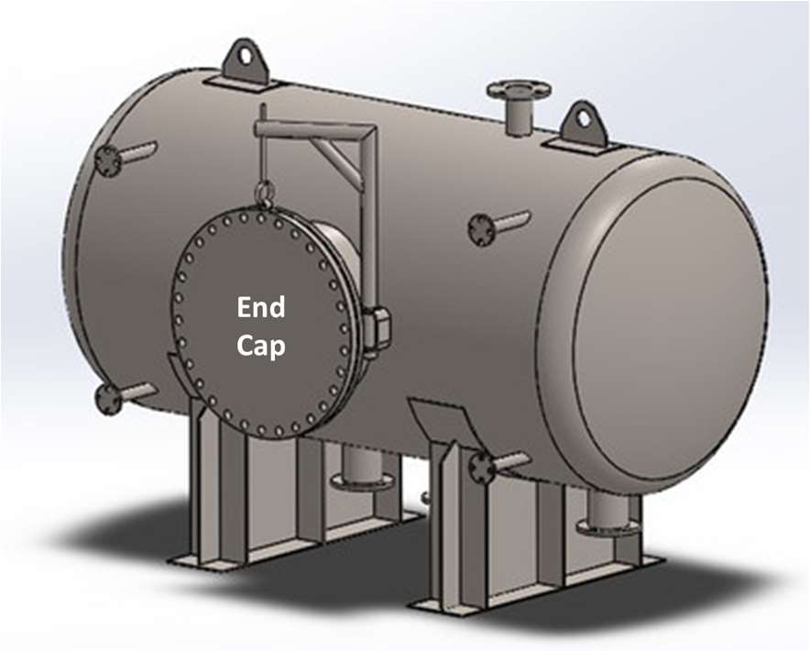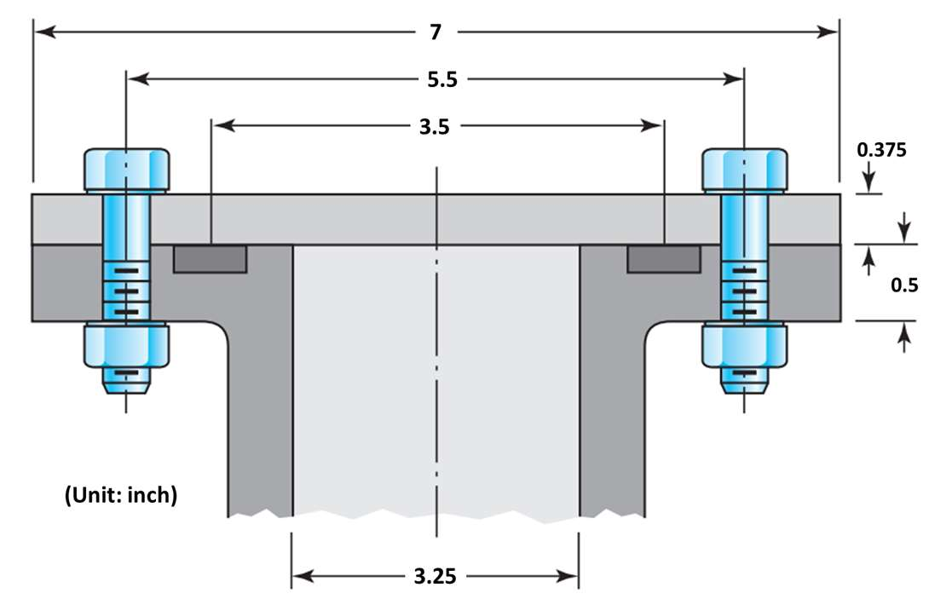

**Solution:**

Nominal major diameter of .

Therefore, I select washer size from Table A-33 with maximum thickness .

From Table A-31, the nut height is .

Because for the given bolt specifications, with two threads beyond the nut,

The minimum length of the bolts per Table A-17 is equal to

The thread length of inch-series bolts is (Table 8-7)

Length of unthreaded portion in grip:

Length of threaded portion in grip:

Area of unthreaded portion:

Area of threaded portion (from Table 8-1):

Fastener stiffness:

Eq. 8-20: the spring rate or stiffness of steel frustum

Eq. 8-20: the spring rate or stiffness of upper cast iron frustum

Eq. 8-20: the spring rate or stiffness of lower cast iron frustum

Total member stiffness:

The stiffness constant of the joint:

Proof strength (From Table 8-9):

Because the end cap has to be removed frequently for maintenance purpose, it is non-permanent connection.

From Eq. 8-31 and 8-32, I can know that

The load is

Yielding factor of safety, Eq. 8-28:

Overload factor of safety, Eq. 8-29:

Separation factor of safety, Eq. 8-30:

# **Problem 3**

Continued from Question 02, the gas force on end cap is cycled between 0 and 10 kips. Determine the fatigue factor of safety for the bolts using failure criteria of (a) Goodman, and (b) Gerber.

Among all considered failure scenarios, which mode is the riskiest for failure?

**Solution:**

Goodman: From Table 8-9, , and from Table 8-17,

Eq. 8-45:

Gerber:

Eq. 8-46:

Yielding is the riskiest for failure.